Ground Segment Development Plan
for
Radio & Plasma Wave Investigation (RPWI)
JUICE

Leading Funding Agency (LFA): Swedish National Space Board (SNSB)
Box 4006, SE-171 04 Solna, Sweden
Tel.: +46-(0)8-627 6480, Fax: N/A.
Email: rymdstyrelsen@snsb.se
LFA Contact: Johan Köhler, Email: Johan.Kohler@snsb.se

Jan-Erik Wahlund (PI)
Swedish Institute of Space Physics
Box 537, SE-751 21 Uppsala, Sweden
Tel.: +46-(0)18-471 5946
+46-(0)76-76 97 877
Fax: +46-(0)18-471 5905
Email: jwe@irfu.se

Jan E. S. Bergman (IM)
Swedish Institute of Space Physics
Box 537, SE-751 21 Uppsala, Sweden
Tel.: +46-(0)18-471 5916
+46-(0)70-746 65 69
Fax: +46-(0)18-471 5905
Email: jb@irfu.se
Baptiste Cecconi (Co-PI)
LESIA-Observatoire de Paris, 5 place Jules Janssen, 92190 Meudon, France
Tel.: +33-(0)1-45 07 77 59
Fax: +33-(0)1-45 07 28 06
Email: baptiste.cecconi@obspm.fr
Ondrej Santolik (Co-PI)
Institute of Atmospheric Physics
Bocni II/1401, 12131 Prague 4-Sporilov
Czech Republic
Tel.: +420 267 103 083
Fax: +420 272 763 745
Email: os@ufa.cas.cz
Yasumasa Kasaba (Co-PI)
Department of Geophysics, Tohoku University
Graduate School of Science, 6-3 Aramaki aza Aoba, Aoba-ku, Sendai 980-8578, Japan
Tel.: +81-22-795 6734
Fax: +81-22-795 6406
Email: kasaba@pat.gp.tohoku.ac.jp
Hanna Rothkaehl (Co-PI)
Space Research Centre of the Polish
Academy of Sciences
00-716 Bartycka 18A, Warsaw, Poland
Tel.: +48-22-4966-418
Fax: +48-22 8403-131
Email: hrot@cbk.waw.pl
Ingo Müller-Wodarg (Co-PI)
Space and Atmospheric Physics group
Imperial College London, London, UK
Tel.: +44-(0)20-7594 7674
Fax: N/A
Email: i.mueller-wodarg@imperial.ac.uk

APPROVAL
Title: Ground Segment Development Plan for Radio & Plasma Wave Investigation (RPWI) JUICE

Issue: 1 | Revision: 0
Author: David Andrews | Date: 25/03/2022
Approved by: | Date:
XXX Electronic signature of approver XXXX

CHANGE LOG
Reason for change | Issue | Revision | Date
First issue for iteration within RPWI | 1 | 0 | 25/03/2022

CHANGE RECORD
Issue 1 | Revision 0
Reason for change | Date | Paragraph(s)
First version issued for approval, updated after discussion of draft within the RPWI Team | XXX | XXX

DISTRIBUTION LIST
Issue X | Revision X | Date X
Recipient | Affiliation | Comments
JUICE Project Office | ESA/ESTEC
RPWI Team
XXX

Table of Contents
1 INTRODUCTION 5
2 APPLICABLE AND REFERENCE DOCUMENTS Updated FOR PDR doc list 2016-05-24 5
2.1 Applicable Documents 5
2.2 Reference Documents 7
2.3 Other Reference Documents 8
3 the rpwi gs 8
3.1 Overview 9
3.2 RPWI GS Requirements 9
3.3 RPWI GS Design 9
3.4 RPWI GS Development schedule 9
3.5 9
4 ACRONYMS DELETe those not used in document 9
ANNEX 1 12

INTRODUCTION
This is the development plan for the JUICE RPWI Ground Segment (GS). The GS comprises a range of software tools used to process instrument telemetry (science, housekeeping data and events), handle metadata, produce summary and survey plots, and support the operation and maintainance of the instrument. The GS interfaces primarily to the SOC and to the various institutes that comprise the RPWI consortium. Different software components of the GS have different functionalities, and will run actively at different sites, both remotely at SOC and in-house at the PI institute (IRF Uppsala).

The RPWI GS is primarily a new development, although components are re-used and/or re-purposed where feasible and appropriate. To support development of a system of software intended to be operated for the anticipated long duration of the JUICE mission, the bulk of the development is conducted in the high-level Python language. Compared to Earth-orbiting space physics missions, the total RPWI telemetry rate is necessarily lower, placing lower demands on the performance of the system in processing and calibrating science data, making the use of a high-level language feasible throughout much of the pipeline. Suitable elements can be parallelized to improve performance.

Development of the RPWI GS is coordinated from IRF Uppsala and hosted on our local gitlab server, where a full history of software releases is maintained, along with features for continuous integration, debugging, and information exchange within the consortium. Where required, code is mirrored to ESA’s facilities.

APPLICABLE AND REFERENCE DOCUMENTS

Applicable Documents
- JUI-EST-SGS-RS-002, JUICE Science Implementation Requirements Document (SIRD)
- ESA/SPC(2012)20, JUICE Science Management Plan (SMP), rev 1
- JUICE RPWI-SOC Data Processing Agreement, JUI-ESAC-SGS-MO-002, Issue 1.0
- JUICE PI-SOC Interface Control Document, JUI-ESAC-SGS-ICD-001
- JUICE Science Data Generation, Validation and Archiving Plan, JUI-ESAC-SGS-PL-006

Reference Documents
- Instrument Operation Concept Document for
Radio & Plasma Wave Investigation (RPWI) JUICE, JUI-IRFU-RPWI-OD-065, Issue 1.6
- MIB database supporting document, JUI-IRFU-RPWI-DP-161, Issue 1.10
- JUICE EID-A, JUI-EST-SYS-EID-001, Issue 2 Revision 7.
- ESDC-PSA-TN-0002, PSA PDS4 Archiving Guide JUI-ESAC-SGS-TN-xxx, JUICE Annex to the PSA PDS4 Archiving Guide
- PDS4 Data Providers Handbook (DPH), Version 1 (1.17.0.0)
- PDS4 Standards Reference (SR), Version 1 (1.17.0.0)
- PDS4 Data Dictionary (DDDB), Version 1 (1.17.0.0)
- PDS4 Information Model Specification (IM), Version 1 (1.17.0.0)
- ESDC-PSA-TN-0002, PSA PDS4 Archiving Guide (former SRE-OE-TN-00174)
- Experiment Interface Document – Part B (EID-B) for RPWI, JUI-IRFU-RPWI-EID-014, Issue 4.2
- JUICE Planning Interface Control Document (PLID) JUI-ESOC-MOC-ICD-003, Issue 1.1

the rpwi gs

Overview
The RPWI instrument suite is a complex set of highly configurable sensors and associated data processing and handling systems. Measurements made on an individual sensor can be processed on board in many different manners by different analogue and digital elements, ultimately leading to a diverse set of data downlinked that must be able to be processed in full by the RPWI GS. This is in addition to instrument housekeeping and [system messages] that need to be interpreted, processed and archived.

RPWI GS Requirements

Overview
All requirements applicable to the RPWI GS flow from the SIRD [AD-1]. In turn, requirements that the software developed for the RPWI GS follows ECSS standards [XXX] is applied, though with the understanding that some conditions may be relaxed owing to the non flight-critical nature of the RPWI GS. While not a requirement on the software or its development, the requirement that the end data products are PDS4 compliant has informed design choices made for the RPWI GS.

Externally imposed requirements
Relevant requirements are copied here from [AD-1].
ID | Origin | Requirement
 | SIRD | Responsibilities of Principal Investigators, For the implementation of the SGS, the PIs are expected to:
SIRD-4.7-2 | SIRD | Provide to SOC calibration files, algorithms, routines needed for the Quick-Look software;
SIRD-4.7-3 | SIRD | Deliver to SOC a pipeline for raw-to-calibrated data processing.
SIRD-4.7-4 | SIRD | Ensure the development, testing, documenting and maintenance of all software necessary for the control, operating, monitoring and testing of the instrument, both on ground and in flight, in accordance with the rules and guidelines established in the EID-A and section 6 of this document.
SIRD-4.7-5 | SIRD | Provide to SOC inputs for the definition and implementation of the science operations planning, data handling and archiving.
SIRD-4.7-6 | SIRD | Provide to SOC instrument performance parameters and operational constraints as part of TM/TC Database, User Manuals, operational procedures and command sequences (as formal deliveries to the Project).
SIRD-4.7-7 | SIRD | Support SOC in development, testing and documenting of all software under SOC responsibility necessary for the testing, operation and data reduction/analysis of any parts of the instrument, in accordance with the rules and guidelines established in the EID-A and implementation requirements in section 6 of this document.
SIRD-4.7-8 | SIRD | Support SOC in the definition of the science operations and preparation of the instrument operation timelines.
SIRD-4.7-11 | SIRD | Monitor operations of their instruments, perform maintenance operations and optimize instrument performance;
SIRD-4.7-12 | SIRD | Run the pipeline for raw-to-calibrated data processing if this option is chosen by the PI [RD01];
SIRD-4.7-13 | SIRD | Provide support required by other PIs for science operations planning purposes, as mutually agreed within the SWT;
SIRD-4.7-14 | SIRD | Within the proprietary period [AD01] deliver raw, calibrated and high level data, including relevant calibration software and /or products and associated documentation, to the JUICE scientific archive;
SIRD-4.7-15 | SIRD | Provide to ESA unlimited access to all processed and analysed data for public relation purpose, even during their proprietary period; this material shall not be used for scientific publications.
SOC-MAN-14 | SIRD | All software under the SOC responsibility shall follow the ECSS standards.
PI-DP-3 | SIRD | The PIs shall support the PS in advising the JUICE Project and the SOC on instruments’ science performance issues relevant to the overall SGS tasks.
PI-DP-5 | SIRD | The PIs shall establish development and deployment plans of instruments operations facilities, equipment and tools (sec 3.4).
PI-DP-6 | SIRD | The PIs shall define instruments operations tools (sec 3.4). Its interfaces shall be agreed with the MOC and SOC.
PI-DP-7 | SIRD | The PIs shall define pre-launch calibration data relevant to SGS tasks and provide them.
PI-DP-11 | SIRD | The PIs shall support SOC in definition and maintenance of interfaces with the SOC for science planning and operations purposes.
PI-DP-12 | SIRD | The PIs shall support SOC in definition and maintenance of interfaces with the SOC for data handling and processing purposes.
PI-DP-13 | SIRD | The PIs shall support SOC in definition and maintenance of interfaces with SOC for data archiving purposes.
PI-CP-6 | SIRD | The PIs shall define, develop, test and validate the Quick-Look Data Analysis software with the instrument commissioning data.
PI-CP-9 | SIRD | The PIs shall ensure that the instrument’s tool for analysis of observations opportunities (sec 3.4 a) is operational 2 years before JOI.
PI-CP-12 | SIRD | The PIs shall design, develop and scientifically validate parts of the SOC Quick-Look Data Analysis tool relevant to their instruments and provide them to SOC in agreed format (see SOC-CP-13).
PI-CP-14 | SIRD | The PIs shall support SOC in developing of the pipeline for telemetry-to-raw data processing (SOC-CP-15) by providing inputs, either in the form of ready to use pipelines or, in exceptional cases, in the form of a co-development of the software with the SOC.
PI-CP-15 | SIRD | The PIs shall design, develop, test and scientifically validate the raw-to-calibrated data pipeline (SOC-CP-16) and provide it to SOC according to an agreed format and schedule.
PI-OP-11 | SIRD | The PIs shall maintain the Quick-Look Data Analysis software and provide its updated versions to SOC (see SOC-OP-7).
PI-OP-15 | SIRD | The PIs shall support SOC in maintenance of the pipeline for conversions of the telemetry packets/ files into raw data (see SOC-OP-12).
PI-OP-16 | SIRD | The PIs shall develop the scientifically validated raw-to-calibrated data pipeline at their premises and maintain the software under version control with the ESA SOC repository. The delivered S/W and supporting files and documentation must enable SOC to install and run the pipeline. (see SOC-OP-13).
PI-OP-17 | SIRD | The PIs shall nominally run the pipeline for raw-to-calibrated data processing at their home institutes.
PI-OP-18 | SIRD | The PIs shall generate calibrated and high-level data products in the format agreed and documented in an ICD between SOC and the PI teams and deliver them to SOC within the proprietary period for ingestion in the ESA archive [AD01].
PI-OP-19 | SIRD | The PIs shall provide details on the data processing to be made available in the ESA archive together with the data products.
PI-OP-20 | SIRD | The format of the data delivered for the ESA archive shall be compatible with the PDS4 standard.
PI-OP-21 | SIRD | The PIs shall support SOC in maintenance of the data retrieval system and helpdesk for external users (see SOC-OP-18).
PI-OP-22 | SIRD | The PIs shall support SOC activities related to the peer review of the archive.
PI-POP-1 | SIRD | For planning purposes, the assumed baseline duration of the Post-Operations Phase shall be 2 years.
PI-POP-2 | SIRD | The PIs shall prepare and provide to SOC raw and calibrated data to complete archiving of the mission data (see SOC-POP-1).
PI-POP-3 | SIRD | The PIs shall prepare and provide to SOC high-level data products to be ingested in the data archive (see SOC-POP-2).
PI-POP-4 | SIRD | The PIs shall provide to SOC instrument data related to science analysis for ingestion in the archive (see SOC-POP-3).
PI-POP-5 | SIRD | The PIs shall support SOC in maintenance of the data retrieval system and helpdesk for external users (see SOC-POP-5).
PI-MAN-5 | SIRD | The PIs shall implement project control systems and procedures focusing on the definition, maintenance and reporting of schedule, costs and configuration information.
PI-MAN-7 | SIRD | All software impacting the science operations processes, especially S/W developed collaboratively between the PI team and the SOC, shall follow standards of good practice in development to be agreed with the SOC. These will be guided by relevant ECSS standards to the degree practicable.
PI-MAN-12 | SIRD | For each interface, an ICD shall be written which shall be approved and signed both by the representative of the SOC-DM/SOC-OM and the PIs.
PI-MAN-13 | SIRD | The document numbering and file names shall follow the standards defined by the Project [AD05] both in the Development and Operations Phases.

Internally imposed requirements
XXX-REQ-RPWI-1: RPWI GS software should be perform sufficiently well that near-real time analysis can be made under necessary circumstances, i.e., processing all TM from a high data rate flyby in a matter of minutes rather than many hours.

XXX-REQ-RPWI-2: RPWI GS software components should be written in Python unless good reason exists not to, using openly distributed and maintained libraries.

XXX-REQ-RPWI-3: For support during NECP, and other mission phases, the TM2RAW pipeline should be configurable to rapidly process RPWI TM data and generate quick look plots.

[XXX]

RPWI GS Design

Overview
The RPWI GS is comprised of several independent modules that process data to specific levels.
The telemetry from the spacecraft, via SOC, is processed to by the TM2RAW pipeline module to PDS “Raw” standards, also referred to as Level 1a (L1a). This step includes, for example, parsing a stream of individual packets, interpreting, decompressing and unpacking (decommutating) the data contained. This step includes the processing of housekeeping data from the instrument. At the next stage the RAW2CAL pipeline further processes the L1a RAW data to PDS “Calibrated” standards, also referred to as L1b, in which scientific data products are transformed into physical units in physically relevant reference frames and calibrated to “scientific” quality. Higher level processing and generation of Level 2 and 3 derived products is taken care of in a third module. At each stage where data are generated, the necessary metadata are also produced or made available, and PDS4 compliant labels are produced at the same instance.

A quick-look analysis tool is also supplied, which forms part of the GS, used primarily for rapid inspection of data quality.

IRF Uppsala, the PI host institute, has the ability to run all elements independently, although the primary instances of the TM2RAW and RAW2CAL pipelines will be hosted at SOC.

Design principles
The RPWI GS is to a large degree a new software development, utilising existing components where feasible, including those that have supported the design and operation of the instrument suite during its development and testing on ground.

The core functions of the pipeline are primarily written in Python. This high-level language was selected to provide continuity through all levels and components of the GS. Initial estimates suggest that performance even single-threaded is sufficient for the RPWI use case. Standard Python tools and practices are used, e.g. the “PIP” Python packaging system, for ease of later building the Docker containers, dynamically generated documentation using Sphinx, code style validation using Flake8, …. A top-level Python package, “RPWI Pipeline”, provides the central backbone of the pipeline.

All RPWI GS software will be deployable into Docker containers, and tested using a continuous integration approach on our GitLab server. All source code for formal releases will be pushed to SOCs own servers according to [AD_RPWI_SOC_ICD].

Each Pipeline component should run autonomously, processing new data as it becomes available. In addition, specific re-processing activities may be commanded that cover selected (or complete) time periods. To facilitate this, each pipeline needs some internal record keeping over the processing state of each input, and all outputs retain in their metadata a full traceability of the code, calibrations, and other relevant information used in their production.

To ensure PDS4 compliance in the final data products, the RPWI GS will attach necessary metadata to the individual CDF files, so that PDS4 labels can be generated dynamically from the CDF itself with only limited additional processing and information.

TM2RAW
The TM2RAW pipeline takes care of the processing of RPWI packets downlinked from the spacecraft and retrieved via SOC. The underlying TM data cannot be archived according to the PDS standard (SOC will retain the TM data however) – the RAW quality data is the first level suitable for archiving within PSA. The science data output of TM2RAW will correspond to PDS4 RAW level data, also referred to as Level 1a (L1a).

The TM2RAW pipeline implements the following functions
- Reading of telemetry stream (files) supplied by SOC, retrieved via EDDS
- Parsing of the MiB to be able to dynamically interpret headers and HK packet contents
- Filtering of instrument HK packets, and “calibration” of their contents to turn e.g. digital numbers into physical temperatures etc., again using the MiB
- Conversion of spacecraft clock to UTC timestamps
- Grouping of science packets and decompression of their science payloads
- Processing of science data according to the instrument configuration, as described in the AUX field of each science packet, and transformation into useable data structures in Python
- Concatenation of science data into CDF files
- Production of survey thumbnail plots
- Generation, and transfer of necessary metadata throughout the processing steps
- Generation of PDS4 labels from stored data and metadata in CDF files
- Archive preparation steps, such as PDS4 validations
- Maintenance of an internal database for processing and re-processing of data
- Logging of all relevant messages during execution

A redundant copy of TM2RAW will be hosted at IRF Uppsala. A further “development” instance of TM2RAW will also be configured that can be used for the continuous processing of data from the RPWI engineering model(s) as part of the testing procedures for DPU (flight) software upgrades prior to their submission to ESA for eventual patching to the flight unit.

A functional block diagram covering TM2RAW is shown in Figure XXX_TM2RAW.

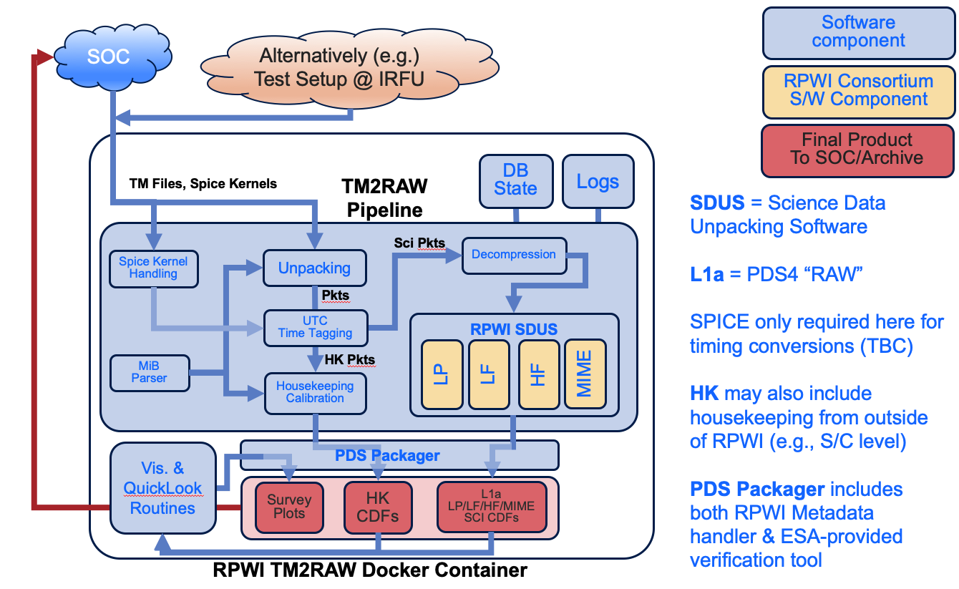
Figure XXX_TM2RAW: Block diagram covering the TM2RAW pipeline.

RAW2CAL
The RAW2CAL pipeline operates only on the output from the TM2RAW pipeline, that is to say the data “sources” are only those complete L1a CDF files already produced. RAW2CAL then performs various calibration and transformations e.g., converting the telemetry units of the RAW data into physical units in a relevant reference frame. The “CAL” data products should be then be fully independent of the instrument itself. Aside from empirically or otherwise determined calibration (transfer) functions, RAW2CAL will make extensive use of the NASA NAIF SPICE software and ESA-provided SPICE kernels to transform data between reference frames (i.e., from sensor to physical frames).

The following functions need to be implemented by the RAW2CAL pipeline
- Processing of each type of CDF data product generated by TM2RAW
- Reading and verifying any calibration information, tables or functions required
- Calibration of the data, by applying e.g. known or dynamically constructed transfer functions
- Rotation from sensor frames to physical frames
- Generation and transfer of metadata at all stages of this process into the CAL CDF files
- Production of CAL CDF files
- Production of survey thumbnail plots
- Generation, and transfer of necessary metadata throughout the processing steps
- Generation of PDS4 labels from stored data and metadata in CDF files
- Archive preparation steps, such as PDS4 validations
- Maintenance of an internal database for processing and re-processing of data
- Logging of all relevant messages during execution

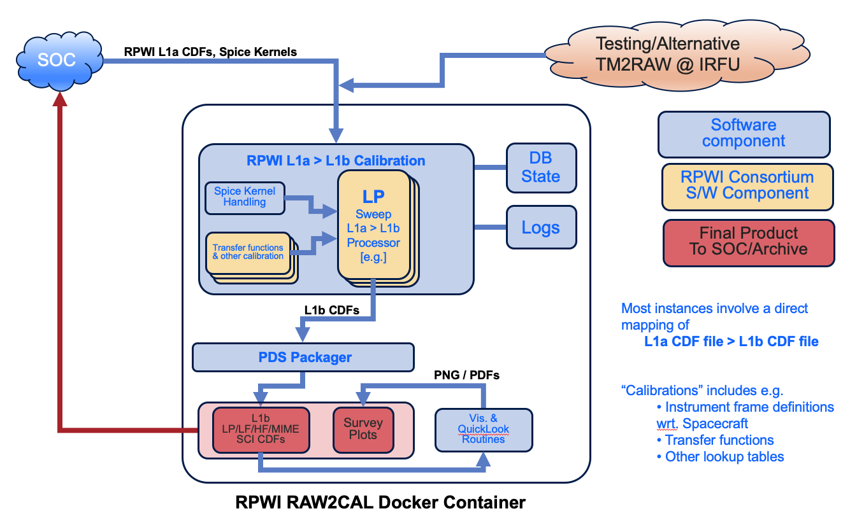
Figure XXX_RAW2CAL: Block diagram covering the RAW2CAL pipeline. A single named CDF processing component is shown, “LP Sweep L1a > L1b Processor”, but equivalent components will be present for all L1a CDF file types generated earlier by TM2RAW.

High level pipeline
The High Level Pipeline (HLPIPE) is tasked with generating high level derived products. These will be generated from L1b calibrated data output from the RAW2CAL Pipeline. In addition, these data products will be heavily reliant on the spacecraft ephemerides, data cleaning routines, and data produced from other instruments on the spacecraft (e.g., to rotate quantities into coordinate systems based on the DC magnetic field vector).

The following functions need to be implemented by HLPIPE
- Generation of each identified high level data product from its (multiple) input data sources
- Production of CDF files for each data product
- Generation, and transfer of necessary metadata throughout the processing steps
- Production of survey thumbnail plots
- Generation of PDS4 labels from stored data and metadata in CDF files
- Archive preparation steps, such as PDS4 validations
- Maintenance of an internal database for processing and re-processing of data
- Logging of all relevant messages during execution

Quick Look Analysis Tool
The Quick Look Analysis Tool (QLAT) will be available for on-demand rapid viewing of the outputs primarily of the TM2RAW and RAW2CAL pipelines. This will be supplied as a system running in a Docker container, to ESA but also within the RPWI team. The QLAT will access and plot the data contained in the CDF files produced by the pipeline(s), using routines that are housed in a Python module that is openly available for all eventual users of the RPWI data set. As a baseline, this will be developed as a module of the existing PyRFU package, a general-purpose spacecraft data analysis package developed at IRFU.

Visualisation and browsing of these data will be provided using a Jupyter notebook interface (apposite for JUICE), exposed from the Docker container via a standard browser interface. The intention is that while by default this Jupyter notebook will provide a quick and easy first view of the RPWI data for a given time interval, it can also be interactively controlled by the end user, and will make use of the same data handling and plotting routines that will be actively developed and maintained by the RPWI consortium. A schematic illustration of the RPWI QLAT is given in Figure: XXX_QLAT.

The RPWI QLAT will implement the following functions
- Efficient browsing in time windows of L1a, L1b and higher level products generated by other RPWI GS components
- Dynamic zoom from snapshot levels up to > days of operations
- Predicted and as-flown trajectory information display
- Display various SPICE-derived quantities, i.e. relevant ephemerides, shadowing state of the RPWI LP sensors etc.
- Display of all RPWI HK and relevant spacecraft HK parameters (e.g., solar array angles)
- Display of RPWI messages
- Display of the RPWI instrument configuration / operating mode
- Display of event lists
- Configuration of viewing parameters

At a lower priority, the intent is also to supply the following additional functions on a best effort basis
- Easy viewing in parallel of relevant MAG and PEP data
- Predicted observations, TM rates when viewed into the future.

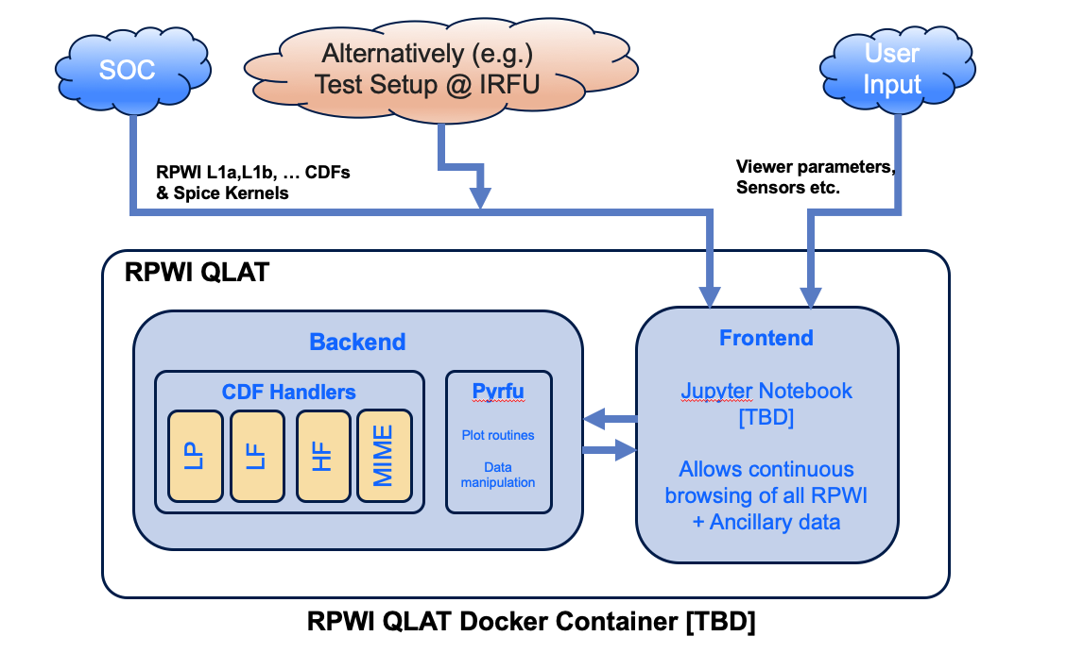
Figure XXX_QLAT: Current proposed architecture for the RPWI QLAT.

PDS4 Archiving Utilities & Packager
All RPWI data will be archived firstly in the ESA PSA and must conform to PDS4 standards [XXX], include the ESA JUICE PDS4 Annex [XXX]. The procedures used to achieve this are schematically illustrated in Figure XXX-PDS4. To ensure this, necessary metadata will be generated at each processing step and retained. As the processing stages progress, and data to be eventually stored as CDF files is generated, relevant metadata are dynamically created (e.g., processing time, input file dependencies, versioning information etc.). Metadata are directly stored as attributes within the CDF files. When a processing step is completed resulting in a complete L1a data product (for example), a template system is used to generate a valid PDS4 xml label containing a full set of metadata for the product. The template xml file is populated dynamically based on the data and metadata already contained in the CDF files. This approach will also be used for higher level products, not only L1a data. Subsequently, the PDS4 Packager together with RPWI-specific Python scripts (TBC) will be used to produce valid PDS4 bundles, and deliver them [for review/to ESA].

Duplicate metadata is thus always provided (in the product XML label and in the CDF file). Deviations should not occur as the XML label is generated at the final step, not during intermediate processing. All major RPWI data products will be generated as CDF files, but it is not impossible that some minor data sets at higher level (e.g., event lists) may be provided in some other PDS4 compliant format.

RPWI data for archiving will need to conform to the specifications outlined in XXX three data dictionaries, namely

- The PDS standard dictionary
- The JUICE mission dictionary
- The RPWI-specific metadata definitions [TBD]
- (XXX).
Verification of compliance will be made for each product using the ESA provided PDS4 tools as part of the generation of PDS4 bundles.

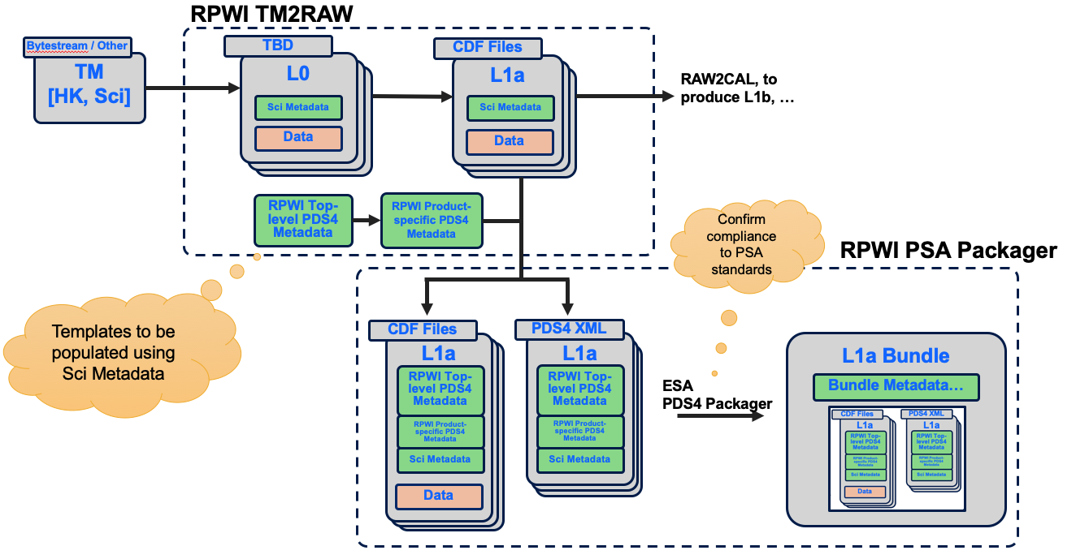
Figure XXX-PDS4: Block diagram illustrating the generation of PDS4 compliant bundles from the output L1a (“Raw”) CDF files produced by TM2RAW. Essentially identical approaches can be taken for outputs of RAW2CAL and HLPIPE.

All RPWI data products are assigned a Logical Identifier (LID) within the PDS4 system. These are given below in Table: XXX-LIDS, which also serves to provide an overview of the data generated by RPWI as it will appear in the PSA.

Bundle_ID | Collection_ID | Product_ID |  |  |  | Name / SID
 |  | prefix | suffix | date | version
urn:esa:psa:juice_rpwi | data_raw | rpwi_raw_lp | _swp | _YYYYMMDD | _vXX.YY.ZZZ | 2
 |  |  | _e24 |  |  | 4
 |  |  | _e694 |  |  | 3
 |  |  | _e763 |  |  | 1
 |  |  | _e49k |  |  | 5

Table XXX-LIDS: PDS4 LIDS for all RPWI data products. Placeholder, see instead https://docs.google.com/spreadsheets/d/10f8MJ-HcSMpQs_CVym1DX7HZKa9QvfgecwKD3tu5cyI/edit#gid=1517679485

RPWI GS Development

Development approach
IRF Uppsala leads the RPWI GS activity, and has the sole responsibility for the development of all components of the various pipelines. The only exceptions relate to those software elements that need more direct expertise regarding the individual sensors of RPWI than is available in house. Specifically,
- for TM2RAW, the science data unpacking software (SDUS) elements that take as input decompressed science packets and output their payloads in Python & CDF-friendly data structures are given as responsibilities to the hardware responsible teams within RPWI
- similarly, for RAW2CAL, hardware responsible teams within RPWI are tasked with delivering software that implements the calibration and transformation steps necessary to generate L1b data from L1a.
- within the high-level pipeline, a more flexible approach will likely be required and can be accommodated since this pipeline will only run at IRF Uppsala.

Throughout development, IRF Uppsala intends to follow applicable ECSS standards, subject to any tailoring specific to PI-supplied JUICE GS software, i.e., non-flight critical systems. In order to manage this activity and handle multiple contributing teams, development work is hosted on a server at IRF Uppsala running GitLab, providing release managements, continuous integration, version control etc. Various other industry-standard tools and approaches will be used throughout this activity. Code in Python will be checked for compliance against the “Flake8” standards, for example, to ensure readability and maintainability over the life of the project.

The use of proprietary software will be avoided for all components that will operate outside of IRF Uppsala, and will moreover be kept to a minimum throughout.

Product Tree
The totality of the RPWI GS software can be considered to comprise the following elements, where we note the responsibilities for development activities (IRF if not otherwise listed).
Item | Ownership (if not IRF)
TM2RAW
- Framework & Docker container
- MiB interface
- HK processing
- Science Data Unpacking Software (x4) | RPWI Sensor Teams
- L1a & HK summary plot software
RAW2CAL
- Framework & Docker container
- L1a to L1b Processing modules (x4) | RPWI Sensor Teams
- L1b summary plot software
HLPIPE
- Framework and Docker containers
- L1b to L2 and L3 processing modules | Various RPWI teams
- L2 & L3 summary plot software | Various RPWI teams
QLAT
- Framework and Docker Container
- Frontend [Jupyter-based]
- Backend CDF handlers | Various RPWI teams
PDS4 Validator | SOC [IRF integration]
RPWI Python end-user package [PyRFU]
Documentation
Table XXX-PT: Core components of the RPWI GS, and their operational ownership within RPWI.

Development schedule
The development schedule is dictated by the project milestones given in Table XXX-MS. Significantly, much of the pre-launch development is driven by internal needs within RPWI, as the GS is required for efficient support and analysis of data for the testing of updates to the RPWI flight software.

Milestone | Date
TM2RAW deployed for end-to-end tests at IRF Uppsala | Q3 2022
QLAT preliminary version for internal use | Q4 2022
RAW2CAL preliminary version available to support NECP activities and analysis | NECP – 2 mo
First delivery of the telemetry-to- raw pipeline S/W to SOC | NECP + 2mo (Q4/2022*)
Telemetry-to-raw pipeline SW integration and testing completed | EGA1 - 3mo (Q1/2023*)
First delivery of the calibration pipeline S/W to SOC | IR – 3mo (Q4/2027*)
Calibration pipeline SW integration and testing completed | RR – 3mo (Q4/2028*)
First delivery of quick-look analysis S/W to SOC | IR – 3mo (Q4/2027*)
QLA S/W integration and testing completed | RR – 3mo (Q4/2028*)
Table XXX-MS: Key milestones in the RPWI GS development. Bold milestones are imposed by ESA requirements in AD-XXX.

Table 1 Example table and caption

ACRONYMS DELETe those not used in document
DPU Digital Processing Units
DRB Delivery Review Board
DRD Document Requirements Definition
EBOX Electronics Box
ECSS European Cooperation for Space Standarisation
EEE Electrical and Electronic Equipment
EGSE Electrical Ground Support Equipment
EID Experiment Interface Document
EM Engineering Model
EOL End of Life
FM Flight Model
FMEA Failure Modes and Effects Analysis
FRODO medium Frequency RadiO and Density Observer
FS Flight Spare
FTA Fault Tree Analysis
GANDALF GANymede plasma Density And Low-Frequency wave instrument
GSE Ground Support Equipment
HF High Frequency
HSIA Hardware Software Interaction Analysis
ICD Interface Control Document
JENRAGE Jupiter ENvironment Radio Astronomy and Ganymede Exploration
JUICE JUpiter Icy moons Explorer
LF Low Frequency
LP Langmuir Probe
LP-PWI Langmuir Probe – Plasma Wave Instrument
LVPS Low Voltage Power Supply
MF Medium Frequency
MGSE Mechanical Ground Support Equipment
MIME Mutual IMpedance Experiment
NCR Non-Conformance Report
NRB Non-conformance Review Board
PA Product Assurance
PAM Product Assurance Manager
PAAM Product Assurance Assistant Manager
PI Principal Investigator
PTR Post Test Review
QA Quality Assurance
QL Qualification Test Level
QM Qualification Model
RFA Request For Approval
RFD Request For Deviation
RFW Request For Waiver
RPWI Radio & Plasma Wave Investigation
RWI Radio Wave Instrument
SCM Search Coil Magnetometer
SEE Single Event Effect
SET Single Event Transient
SEU Single Event Upset
SPA Software Product Assurance
SPF Single Point Failure
SpW Space Wire
STM Structural Thermal Model
WCA Worst Case Analysis

AsI Astronomical Institute, Prague
CBK Space Research Centre of the Polish Academy of Sciences
CDPP Centre de Données de la Physique des Plasmas
CNES Centre National d'Etudes Spatiales
CNRS Centre National de la Recherche Scientifique
ESA European Space Agency
IAP Institute of Atmospheric Physics, Prague
Imperial Imperial College London
IRAP Institut de Recherche en Astrophysique et Planétologie
IRFU Swedish Institute of Space Physics, Uppsala
ISAS ISAS/JAXA, Tokyo
JAXA Japanese Aerospace Exploration Agency
KaU Kanazawa University
KTH Royal Institute of Technology
KyU Kyoto University
LATMOS Laboratoire Atmosphères, Milieux, Observations Spatiales
LESIA Laboratoire d’Etudes Spatiales et d’Instrumentation en Astrophysique
LPP Laboratoire de Physique des Plasmas
LPC2E Laboratoire de Physique et Chimie de l’Environnement et de l’Espace
NagU Nagoya University
NASA National Aeronautics and Space Agency
PSA Planetary Science Archive
PDS Planetary Data Service
Sheffield University of Sheffield
SRI Space Research Institute, Graz
TU Tohoku University
UC University of Cologne

ANNEX 1
- XXX LID / Data table probably goes here.

